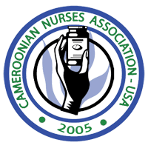
LEVEL | BLOOD PRESSURE NUMBERS | RESULTS
NORMAL | BELOW 120/80 | *Good for you  *Check blood pressure yearly
PREHYPERTENSION | 120/80 TO 139/89 | *You are more likely to end up with high blood pressure.  *Take action to prevent it.
HIGH | 140/90 AND ABOVE | *Ask your Doctor how to lower it  *Check your BP often

FREE BLOOD PRESSURE CHECK AT:
CVS, GIANT, TARGET, WAL-MART PHARMACY

MOST GENERICS BP MEDICATIONS AVAILABLE AT :
4 DOLLARS FOR 30 DAYS COUNTS
10 DOLLARS FOR 90 DAYS COUNTS
Available at Target, Wal-Mart for anyone with no health insurance
COSTCO also discount medications and no need to be a member to buy medications at Costco.

